Document: FCILekha PFMS User Guide | Version:12.1



Error: Reference source not found

User Guide
PFMS



APR 2022

Confidentiality

© 2021 TECH MAHINDRA

This document contains information that is proprietary and confidential to TECH MAHINDRA which shall not be disclosed outside Flex Industries Ltd, India, transmitted, or duplicated, used in whole or in part for any purpose other than its intended purpose. Any use or disclosure in whole or in part of this information without express written permission of TECH MAHINDRA Limited is prohibited. Any other company and product names mentioned are used for identification purposes only, and may be trademarks of their respective owners.

Document Control

Revision Details

Date | Author | Version | Page No | Change Reference
 | Santhosh, Siddhant, Amit Dhyani | 12.0 |  | Document Created
4-Apr-2022 | Amit Dhyani | 12.1 |  | Added ‘FCI PFMS merge bank account CVE0050’ process.

TABLE OF CONTENTS
Document: FCILekha PFMS User Guide 0
TABLE OF CONTENTS 3
1. Overview 5
2. SFTP server configuration and XML file sharing 6
3. FCI-PFMS COA Mapping 6
4. Segregation of FCI suppliers into PFMS IA’s and PFMS vendors 6
5. Registration of vendors from FCI FAP to PFMS 7
6. Reporting of FCI transactions categorized as expense, advances and transfers 8
7. FCI PFMS COA Mapping Report (NEW) 9
8. FCI Supplier PFMS Detail Report 10
9. FCI PFMS Rejected Vendor Detail Report 11
10. FCI PFMS Supplier Summary Report 12
11. FCI PFMS EAT Reported Data Report 13
12. FCI PFMS EAT Rejected Data Detail Report 14
13. FCI PFMS EAT Summary Data Report 15
14. PFMS Vendor REJECTIONS 16
15. PFMS EAT Rejections 19
16. FCI PFMS merge bank account CVE0050 22

Overview

The purpose of this training document is to give the intended users step by step operating instructions in doing the PFMS related activities in Oracle Applications 12 ERP system.
The Public Financial Management System (PFMS) is a web-based online software application developed and implemented by the Controller General of Accounts (CGA), Department of Expenditure, Ministry of Finance, Government of India. PFMS started during 2009 with the objective of tracking funds released under all Plan schemes of Government of India, and real time reporting of expenditure at all levels of Programme implementation. Subsequently, the scope was enlarged to cover direct payment to beneficiaries under all Schemes. (Source: https://pfms.nic.in/)
This document provides user with an overview of the xml based reporting of data done by FCI as per the guidelines shared by PFMS.
This integration of FCI FAP with PFMS is divided into following major activities, each of which is discussed further in detail:
• SFTP server configuration and XML file sharing
• FCI-PFMS COA Mapping
• Segregation of FCI suppliers into PFMS IA’s and vendors
• Registration of vendors from FCI FAP to PFMS
• Reporting of FCI transactions categorized as expense, advances and transfers.
The document provides a list of all the custom reports that are available with user to review and take necessary action against the data being reported to and rejected by PFMS.
Abbreviations Used
S No | Abbreviations | Description
1 | FCI | Food Corporation of India
2 | FAP | Financial Accounting Package
3 | EAT | Expense, Advances and transfers
4 | REAT | Receipts, Expense, Advances and transfers
5 | MIS | Management Information System
6 | PFMS | Public Financial Management System
7 | COA | Chart of Accounts
8 | IA | Implementing Agency
9 | DFF | Descriptive flex field.
10 | LGD Code | Local government directory code

SFTP server configuration and XML file sharing
- An SFTP server has been established on existing VM server.
- FCI FAP application places the XML files for vendor registration request as well as EAT MIS on SFTP server.
- PFMS then accesses these XML files from SFTP server, process them and shares acknowledgment XML files for both vendor registration request and EAT MIS.
- FCI FAP application consumes these files from SFTP server and process them to mark the accepted and rejected records in FAP.

FCI-PFMS COA Mapping
When EAT upload process was implemented in the system, a mapping between FCI Account, FCI Product and FCI Scheme was done against the 9 PFMS major heads and their sub-groups. Since then, this mapping is updated at frequent intervals for any new inclusions in FCI COA. The same mapping will be used for reporting of REAT MIS as well. This information is available to end user in the form of report ‘FCI PFMS COA Mapping Report (NEW)’.

Segregation of FCI suppliers into PFMS IA’s and PFMS vendors
PFMS has clarified that there is no provision to create/update any IA from FCI FAP to PFMS via SFTP based integration. Instead, any IA will first have to be created at PFMS and then reverse mapped to FCI FAP application. Similarly, any update to an IA will be first made in PFMS and then in FCI FAP.
In order to capture the details for PFMS IA a DFF is present on ‘Organization’ page on the supplier workbench. Following fields are part of this DFF:
Field | Description | Mandatory
PFMS Payee Type | Implementing agency (A)or Vendor (V) | Yes
PFMS Vendor Type | As per PFMS master from integration document. Default value as per FCI will be 2 i.e. commercial. | Yes
PFMS Code | Unique identification code provided by PFMS to an IA or vendor. User can enter ‘NOT YET AVAILABLE’ for vendors | Yes
State LGD Code | As per PFMS master available on FAP home page | Yes
District LGD Code | As per PFMS master available on FAP home page | Yes

These fields from DFF are a incorporated into ‘Bulk Supplier Upload’ process too. The validations are same as above.
As per discussions with FCI, default value ‘2’ was populated against ‘PFMS Vendor Type’ for all FCI FAP suppliers.
When creating or updating any IA in PFMS, user will need to fill the DFF above in order to mark an FCI FAP supplier as an IA in FAP.
If a FCI supplier is identified as IA by end user, the supplier along with all its bank accounts primary or secondary will be considered as registered in PFMS. This information will be maintained in a custom repository of PFMS IA and PFMS vendors.
Any FCI FAP supplier not marked as IA by the user will be considered a PFMS vendor and will be sent to PFMS for registration.

Registration of vendors from FCI FAP to PFMS
Any FCI FAP supplier not marked as an IA by the user is treated as a PFMS vendor and registered at PFMS using XML based vendor registration request.
To ensure data correction w.r.t to the bank account details of the suppliers in FCI FAP, a check is placed on invoice workbench:
At the time of invoice creation, the system will check
a) Supplier Remit to bank account cannot be left blank.
b) Supplier Remit to bank account name cannot be left blank.
c) Supplier remit to bank account has a valid IFSC code attached. The first 4 characters are alphabets followed by a ZERO and the remaining 6 characters can be alphanumeric.
If any of the above conditions is left out, the system will not allow invoice creation.
An exception can be made to above check for a supplier by adding the supplier number to a custom value set 'FCI_PFMS_NOBANK_VENDROS'. The value set is available with FCI Support User responsibility.
NOTE: A supplier missing any of the mandatory information or not having the field values populated as per the PFMS masters, will not be sent for registration to PFMS. The bank account information is of most importance in this case as invalid/incorrect bank details can lead to non-registration of FCI suppliers as PFMS vendors.
Only primary ownership bank account of a supplier in FAP is sent to PFMS for registration. All the secondary owners of a particular bank account are not registered at PFMS and share the same PFMS agency code against which the primary owner of that bank account is registered in PFMS.
If a supplier A is a secondary owner for a particular bank account, then the PFMS agency code of the primary owner B of the same account will be considered while reporting any expense/advance on the same account for supplier A.
A repository of registered vendors and user identified IA’s is maintained in the system along with the registered bank account details.
The status of all the vendor records accepted or rejected is updated in this repository. A separate report ‘FCI Supplier PFMS Detail Report’ has been provided to access the same information.
Another report ‘FCI PFMS Rejected Vendors’ has been provided to list out rejection reasons for a particular PFMS vendor record.

Reporting of FCI transactions categorized as expense, advances and transfers
Reporting of data from FCI FAP to PFMS as EAT is done for Payables module only. The paid invoices in AP are reported as below:
- Paid standard invoices for PFMS vendors reported as expenses.
- Paid prepayment invoices for PFMS vendors reported as advances.
- Paid standard and prepayment invoices for PFMS IA reported as a transfer.

Since there is no provision in PFMS to report credit/debit invoices, any such invoices paid via a refund payment or otherwise, is not reported.
While reporting the data it is assumed that user has registered the internal bank account against the FCI unit from which payment has been made in PFMS. Also in case of payments made to an IA as a transfer user needs to ensure that the respective bank account of IA is active in PFMS.
No payment data is reported for a vendor if it is found that the vendor bank account to which the payment has been made is not registered in PFMS. System will check this from the repository of the registered PFMS vendors in FAP.
A new report ‘FCI EAT Reported Data’ can be used to review the data that is reported/accepted/rejected by PFMS.
Another report ‘FCI EAT Rejected Data Detail’ report will be available to user to list out rejection details of EAT data.

FCI PFMS COA Mapping Report (NEW)
The report has been designed to provide mapping of FCI Account, FCI Product and FCI Scheme against the 9 PFMS major heads and their sub-groups.
Report Navigation: Payables Responsibility-> View -> Requests -> Submit a New Request -> Single Request
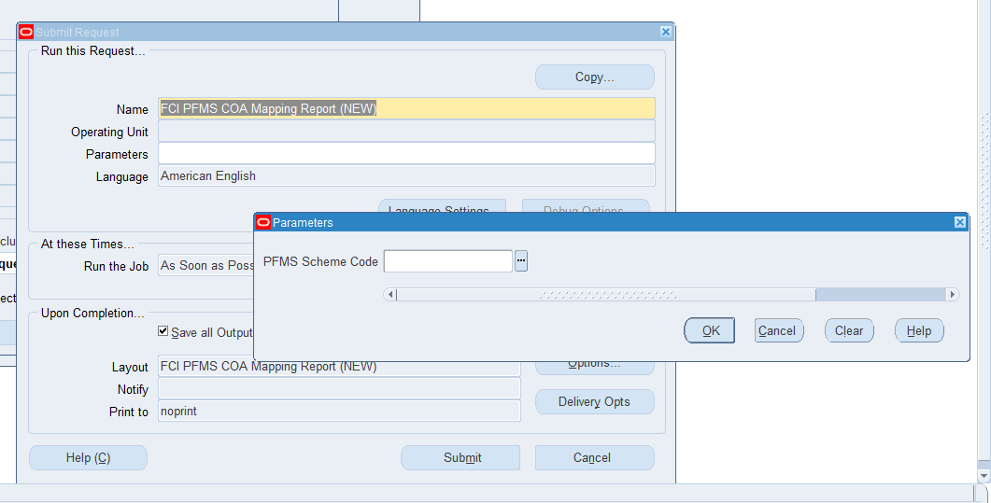

The report run on the basis of provided unit name.
Report access is provided to FCI Payables super User, FCI Payables User and FCI Support user responsibilities.
Sample output attached below

FCI Supplier PFMS Detail Report

User can run this report to view the rejection/registration status of each PFMS Vendor and PFMS Implementing Agency. Only those PFMS Vendor and PFMS Implementing Agency will get reflected in the report that are having site corresponding to the unit for which report is run.
Report Navigation: Payables Responsibility-> View -> Requests -> Submit a New Request -> Single Request
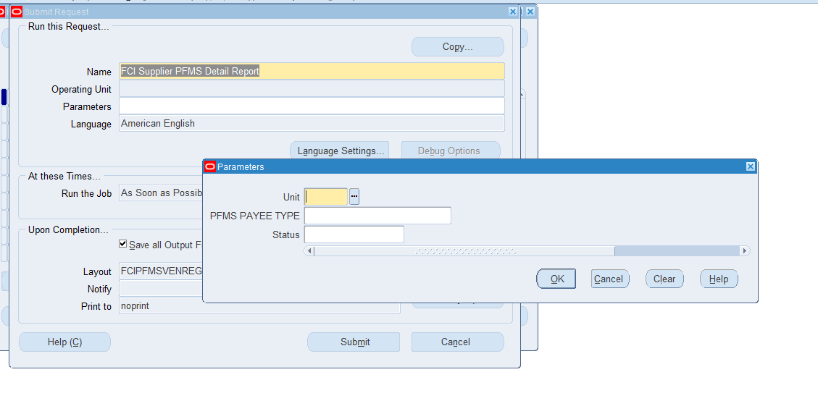
The report run on the basis of provided unit name, PFMS PAYEE TYPE(VENDOR/AGENCY),STATUS(Registered/rejected).
Report access is provided to FCI Payables super User, FCI Payables User and FCI Support user responsibilities.
Sample output attached below

FCI PFMS Rejected Vendor Detail Report

User can use this report to view detailed rejection reason against each of the rejected PFMS vendors.
Report Navigation: Payables Responsibility-> View -> Requests -> Submit a New Request -> Single Request
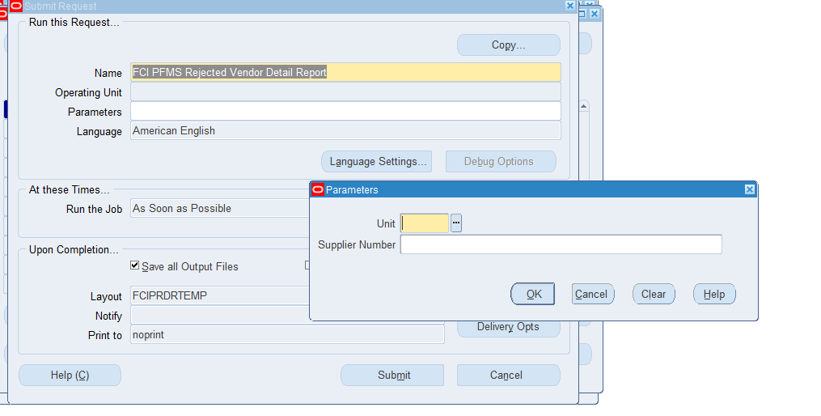
The report run on the basis of provided unit name and Supplier Number.
Report access is provided to FCI Payables super User, FCI Payables User and FCI Support user responsibilities.
Sample output attached below

FCI PFMS Supplier Summary Report

The report has been developed to provide summary (count) of REGISTERED, PENDING and REJECTED record for PFMS Vendor and PFMS Implementing Agency. The report can be run on hierarchy basis.
Report Navigation: Payables Responsibility-> View -> Requests -> Submit a New Request -> Single Request
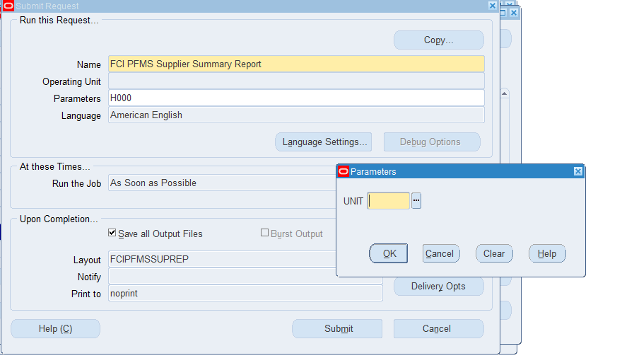

The report run on the basis of provided unit name.
Report access is provided to FCI Payables super User, FCI Payables User and FCI Support user responsibilities.
Sample output attached below

FCI PFMS EAT Reported Data Report
User can use this report to review the status of various invoices reported to PFMS under EAT.
Report Navigation: Payables Responsibility-> View -> Requests -> Submit a New Request -> Single Request
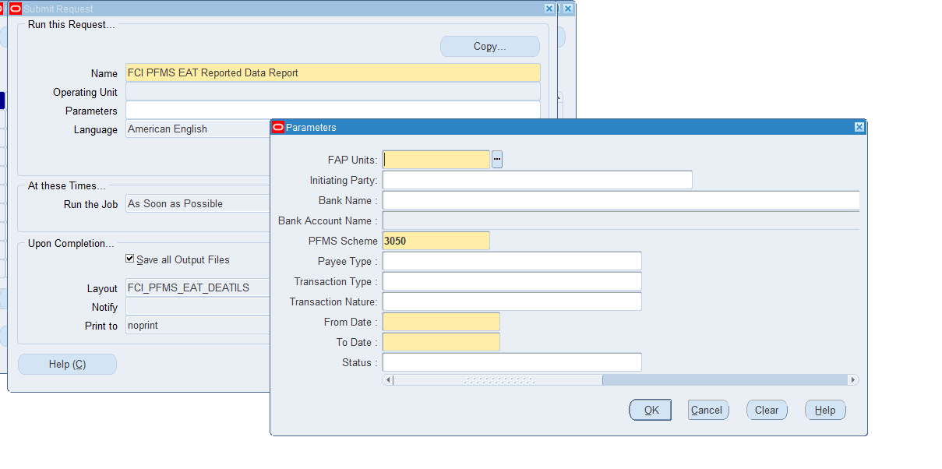
User can use the input parameters to segregate the data based on internal bank account, PFMS scheme, payee type, transaction nature, status and transaction type for a given date range.
Report access is provided to FCI Payables super User, FCI Payables User and FCI Support user responsibilities.
Sample output attached below

FCI PFMS EAT Rejected Data Detail Report
As the name suggests, the report is intended to provide the detail for all the invoices that are rejected by PFMS under EAT. The report can be used to view rejection reason associated against each of the payments.
Report Navigation: Payables Responsibility-> View -> Requests -> Submit a New Request -> Single Request

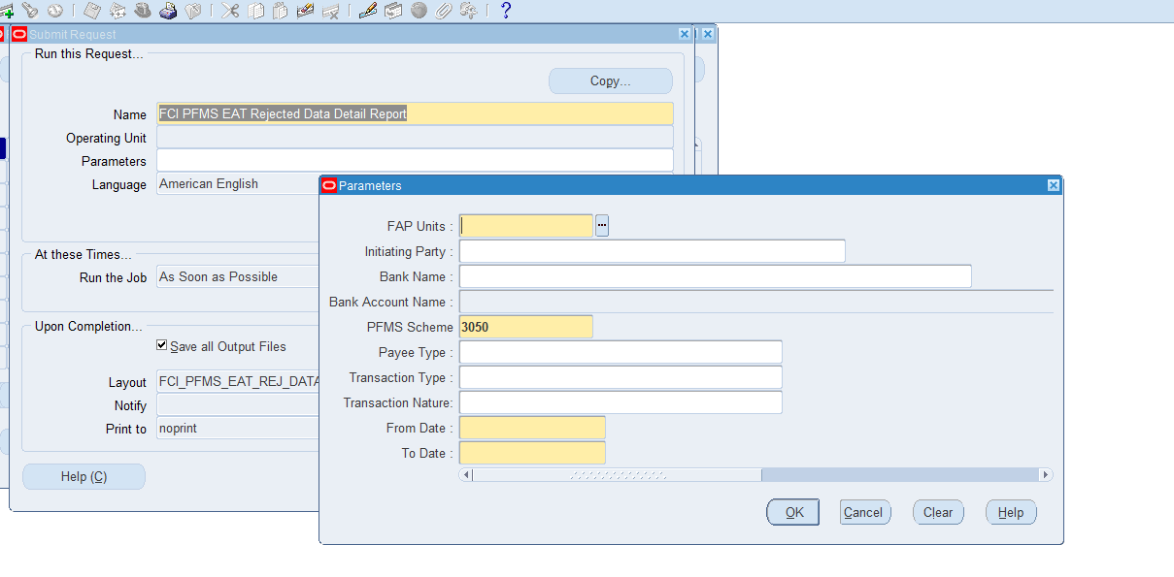
User can use the input parameters to segregate the data based on internal bank account, PFMS scheme, payee type, transaction nature and transaction type for a given date range.
Report access is provided to FCI Payables super User, FCI Payables User and FCI Support user responsibilities.
Sample output attached below

FCI PFMS EAT Summary Data Report
The report is designed to provide summary of the payments accepted/rejected under reported EAT data.
Report Navigation: Payables Responsibility-> View -> Requests -> Submit a New Request -> Single Request
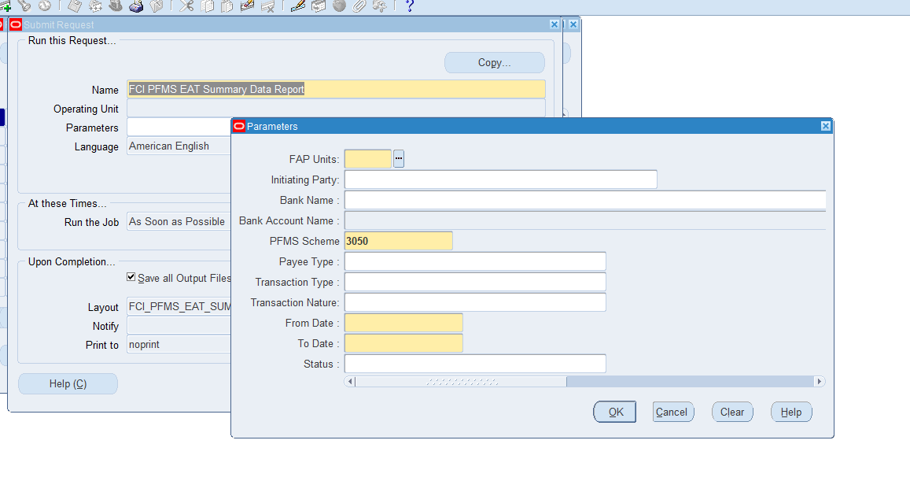
User can use the input parameters to segregate the data based on internal bank account, PFMS scheme, payee type, transaction nature, status and transaction type for a given date range.
Report access is provided to FCI Payables super User, FCI Payables User and FCI Support user responsibilities.
Sample output attached below

PFMS Vendor REJECTIONS
PFMS has provided a complete list of validations that are applicable on each of the vendor registration/update request sent to PFMS. Some of the validations in this is list are not applicable for FCI FAP.
For user reference at the end of this section a complete list of rejections is provided. We have also provided a more detailed explanation for more frequent rejections that are a result of these validations.

- CVE0008: Duplicate Vendor Beneficiary Name, Bank Account No and Bank Name not allowed
This rejection happens when there exist multiple bank account assignments with the vendor, all having same bank name, account number but different IFSC codes. Users are advised to refrain from creating such records as PFMS won’t allow registration of such records.

- CVE0050: Bank Account No for provided Bank Name already exists in PFMS|V00000000000|
This rejection happens when there exist more than one primary bank account owner for same bank name, IFSC code and account number. One of the way user is achieving this in FAP is by adding additional space in front of the account number while creating the bank account with vendor. Users are advised to refrain from creating such records as PFMS won’t allow registration of such records. As a result there will be no reporting of payments made to such bank accounts. In the error description above ‘V00000000000’ will specify the PFMS agency code for the vendor which is already registered with same bank account details.

- CVE0017: Both State and District are not mutually compatible
This rejection occurs when user has specified state and district LGD codes at supplier form DFF that do not belong to each other. There are multiple district LGD codes under each state LGD code and users are supposed to enter these keeping in mind the parent child relationship. A PFMS state/district LGD code master is also available on FAP library page for user reference.

Following is a list of all the validations that are applicable for each of the vendor record that is sent to PFMS. Since we’re not sending AADHAR information, AADHAR based validations are not applicable to FCI FAP vendors.
S.No. | Error Code | Error Description
1 | CVE0001 | Mandatory Tags values are missing.
2 | CVE0002 | Request Source Code as provided by External System is incorrect
3 | CVE0003 | Vendor Beneficiary Type does not exists in PFMS
4 | CVE0004 | Invalid value for GST Number
5 | CVE0005 | Duplicate Batch ID/Message ID not allowed.
6 | CVE0006 | AADHAAR Number should be of 12 digits and must pass the algorithm provided by UIDAI.
7 | CVE0007 | Invalid value for Service Tax number
8 | CVE0008 | Duplicate Vendor Beneficiary Name , Bank Account No and Bank Name not allowed
9 | CVE0009 | Rejected by Bank, As per Bank Account Number is Invalid.
10 | CVE0010 | Bank Name is not as per PFMS Bank Master.
11 | CVE0011 | Invalid value for PAN Number
12 | CVE0012 | One of AADHAAR Number or Bank Account details are mandatory
13 | CVE0013 | Invalid Address.
14 | CVE0014 | Date of birth should be in correct date and less than System Date.
15 | CVE0015 | Mobile number/Phone Number should be of 10 digits only.
16 | CVE0016 | Invalid Batch Format, It should be as CS {Source System Id} DDMMYY {4 digit Sequence}.
17 | CVE0017 | Both State and District are not mutually compatible
18 | CVE0018 | Invalid State Code. It should be as per PFMS Master
19 | CVE0019 | Invalid District Code. It should be as per PFMS Master
20 | CVE0020 | Invalid value for TIN Number
21 | CVE0021 | Invalid value for TAN Number
22 | CVE0022 | Invalid Email Id
23 | CVE0023 | Invalid IFSC Code.
24 | CVE0024 | Invalid Country Code. It should be as per PFMS Master
25 | CVE0025 | Wrong Data Type/Length Format.
26 | CVE0026 | Postal Code should be numeric value
27 | CVE0027 | Error in reading file, File is malformed
28 | CVE0028 | Rejected by Bank, Account No does not exist in Bank
29 | CVE0029 | Blocked Account
30 | CVE0030 | Rejected by Bank, Account status is closed.
31 | CVE0031 | Duplicate Aadhaar Number Found In The File
32 | CVE0032 | Aadhaar Number is not seeded in NPCI
33 | CVE0033 | Vendor Beneficiary Name Len is greater than 99
34 | CVE0034 | Bank Name And IFSC Code are not related to each other
35 | CVE0035 | UID And Account Both Are Invalid
36 | CVE0036 | Bank Not Responded.
37 | CVE0037 | UID is Invalid and account is Rejected due to no response received from bank within specified days
38 | CVE0038 | UID is Invalid and account is closed.
39 | CVE0039 | UID is Invalid and account is blocked.
40 | CVE0040 | UID is Invalid and account is inactive.
41 | CVE0041 | Invalid Vendor Type Code
42 | CVE0042 | Action on Account – Value ‘D’ is applicable only if Purpose is ‘U’
43 | CVE0043 | Invalid Message ID Format
44 | CVE0044 | Message ID should be same as File name without extension
45 | CVW0045 | Vendor Created based on UID, but account is Invalid.
46 | CVW0046 | Vendor Created based on UID, but account is Closed.
47 | CVW0047 | Vendor Created based on UID, but account is Blocked.
48 | CVW0048 | Vendor Created based on account, but UID is Invalid.
49 | CVW0049 | Vendor Created based on UID as account is Rejected due to no response received from bank within specified days
50 | CVE0050 | Bank Account No for provided Bank Name already exists in PFMS
51 | CVE0051 | Invalid F-M-H flag

PFMS EAT Rejections
Just like the validations for vendor registrations, validations are also applicable for each of the payment being reported as expense, advance and transfer.
For user reference at the end of this section a complete list of rejections is provided. We have also provided a more detailed explanation for more frequent rejections that are a result of these validations.
- CPE0015: Initiating Party Code should be PFMS Agency Code
This is a file level rejection, users are advised to check and verify that the FCI unit which has made the payment is having correct ‘Initiating Party PFMS Code’ against the PFMS agency code assigned to the unit in PFMS.
- CPE0016: Invalid Authority Code
This is a file level rejection, since ‘Authority Code’ and ‘Initiating Party PFMS Code’ are same in case of FCI FAP. Users are advised to follow same steps as that of error code CPE0015.
- CPE0035: IFSC Code is invalid.
This is a file level rejection, users are advised to verify the IFSC code for internal bank account through which rejected payment was made. The IFSC code should be same for the internal bank account at PFMS and FCI FAP application.
- CPE0034: Both Account and Aadhar are invalid.
This is a file level rejection, since FCI FAP is not making use of AADHAR for payment disbursement; only account level validations are applicable here. For this rejection code, users need to ensure that the internal bank account through which rejected payment was made, is valid and all the details such as bank name, IFSC code and account number are same at PFMS and FCI FAP application.
- CPE0044: Debit Account no. does not belong to Agency or It status is not valid in PFMS
This is a file level rejection. This can occur if the internal bank account is not registered at PFMS or it is invalid/inactive at PFMS. For this rejection code, users need to ensure that the internal bank account through which rejected payment was made, is valid and all the details such as bank name, IFSC code and account number are same at PFMS and FCI FAP application.
- CPE0007: Invalid Component ID
This is a payment level rejection, the error occurs for those invoices where users have entered a 7-segment combination which as per the mapping between FCI COA and PFMS COA must have a crop year associated with it. But users enter these combinations in ‘Other’ type invoices without a crop year. As a result the record gets rejected.
- CPE0021: Payee Account number does not belongs to Payee code or Payee account is invalid
This is a payment level rejection, this rejection occurs if the bank account details of the supplier, to whom payment was made are not correct or the bank account is missing in PFMS.
For PFMS agency type suppliers, users need to ensure that the all the bank details associated with the supplier that are bank name, IFSC code and account number are same at PFMS and FCI FAP application.
For PFMS vendor type suppliers, get in touch with FAP team to get the bank details rectified/updated if they are not right.
- CPE0033: Account number is marked as Invalid in PFMS.
This is a payment level rejection, and the potential causal for this rejection reason is same as that of error code CPE0033.

Following is a list of all the validations that are applicable for each of the payment being reported as expense, advance and transfer.

S.No. | Error Code | Error Description
1 | CPE0001 | Duplicate Batch ID
2 | CPE0002 | Invalid Batch Format. It should be PNNNNDDMMYYYYXXXXXXX (Total 20 characters. P is fixed for payment file. NNNN refers to the 4 digit Source System Id allotted by PFMS, DDMMYYYY represent the date and XXXXXXX represent running serial no
3 | CPE0003 | Scheme Code does not exist in PFMS
4 | CPE0004 | Payee Type does not exist in PFMS. It can be Vendor (V) or Beneficiary (B) or Implementing Agency (A)
6 | CPE0006 | Verification of Digital Signature Failed if the digitally signed file is received
7 | CPE0007 | Invalid Component ID
8 | CPE0008 | Duplicate payment check based on PFMS Payee Code + Scheme + Sanction No. – This validation has been discontinued
9 | CPE0009 | Mandatory fields value missing
10 | CPE0010 | Net credit Amount should be more than zero
11 | CPE0011 | Message Id not as per defined format source +  EATPAYREQ + DDMMYwY+Seq No.
12 | CPE0012 | Duplicate Message ID
13 | CPE0013 | Record Count Should be more than Zero
14 | CPE0014 | Control Sum should be more than Zero
15 | CPE0015 | Initiating Party Code should be PFMS Agency Code
16 | CPE0016 | Invalid Authority Code
17 | CPE0017 | Invalid Bank/Post Office Name – This validation has been discontinued
18 | CPE0018 | Deduction Applicable. It can be ‘Y’ or ‘N’
19 | CPE0019 | Wrong Data Type/Data Length/Data Type Format
21 | CPE0021 | Payee Account number does not belongs to Payee code or Payee account is invalid
22 | CPE0022 | UID is invalid
25 | CPE0025 | Invalid Payment Mode. Allowed values are 1,2,3,4,5 and 6 only
26 | CPE0026 | Modes 1,2 ,3 4, 5 are applicable for MIS type transactions only and Mode 6 is exclusive modes & can’t be clubbed with other modes in one file and is applicable for Non MIS transactions only
27 | CPE0027 | Invalid Expense Type. It can be ‘R’ or ‘C’
28 | CPE0028 | Invalid Transaction type. It can be ‘N’ or ‘R’
30 | CPE0030 | Invalid Date Time Format. It should be YYYY-MM-DDTHH:MM:SS
32 | CPE0032 | Duplicate EndToEndId Not allowed in the file.
33 | CPE0033 | Account number is marked as Invalid in PFMS.
34 | CPE0034 | Both Account and Aadhar are invalid.
35 | CPE0035 | IFSCCode is invalid.
36 | CPE0036 | Duplicate payment check based on EndToEndID fails across already processed transactions
37 | CPE0037 | Control Sum should be same as total of Net credit Amount + Deduction amount i.e. Sum of Gross Payments
38 | CPE0038 | One of AADHAAR Number or Bank Account details are mandatory
39 | CPE0039 | Invalid value for Transaction Purpose, It should be ‘P’ for Payment or ‘M’ for MIS.
40 | CPE0040 | Error in reading file, File is malformed or Failed during schema validation
41 | CPE0041 | Invalid Project ID
42 | CPE0042 | Payee can be paid only once through one payment file i.e. Multiple records of same Payee code are not allowed – This validation has been discontinued
43 | CPE0043 | Invalid for Deduction Type Code
44 | CPE0044 | Debit Account no. does not belong to Agency or It status is not valid in PFMS
45 | CPE0045 | Invalid DBT Mission Scheme Code.This error code is not in use
46 | CPE0046 | Payment Period To Date should be less <= Payment Period From Date. This error code is not in use
47 | CPE0047 | Payment Period not provided for DBT Payment. This error code is not in use
48 | CPE0048 | Message ID should be same as File name without extension
49 | CPE0049 | Digital signatures Consistence check fail
50 | CPE0050 | Digital signatures sent in payment file are not enrolled in PFMS
51 | CPE0051 | Invalid Financial Year
52 | CPE0052 | External System Payment Identifier should be unique throughout the life cycle in System Integration.  If the payment file is rejected from PFMS, then the modified Payment File can be sent from External System with the same identifier- This validation has been removed
53 | CPE0053 | Beneficiary Category must be eligible to get payments under the desired Scheme.
54 | CPE0054 | Actual Transaction date is mandatory for MIS
55 | CPE0055 | Sanction date is mandatory
56 | CPE0056 | Sanction date should be in the provided financial year
57 | CPE0057 | Actual Transaction date should be in the provided financial year for MIS
58 | CPE0058 | Actual Transaction date should be CurrentDate or blank for EPayment
59 | CPE0059 | Deduction applicable is "Y", but amount is not mentioned and vice versa. (means deduction applicable ‘N’, but amount mentioned)
60 | CPE0060 | Total sum of components amount should be equal to the corresponding payee net credit amount+Deduction amount.
61 | CPE0061 | Sanction Number already exist
62 | CPE0062 | Vendor Name is not in English, Kindly resend vendor updation request with name in english
63 | CPE0063 | Invalid Source System Id. Source Id does not exist in PFMS
64 | CPE0064 | Number of Record Counts does not match with the total number of Payees
65 | CPE0065 | Invalid Transaction Nature. Possible values are ‘E’, ‘A’ or ‘T’

FCI PFMS merge bank account CVE0050
CVE0050: Bank Account No for provided Bank Name already exists in PFMS|V00000000000|
This rejection happens when there exist more than one primary bank account owner for same bank name and account number combination. In the error description above ‘V00000000000’ will specify the PFMS agency code for the vendor which is already registered with same bank account details at PFMS.
Suggested solution:
This solution is applicable at FCI unit level. Each of the units can run ‘FCI PFMS Rejected Vendor Detail Report’ available in Payables responsibility to view the details of their respective vendors rejected due to rejection code CVE0050. Users can refer to column ‘REJECTION_REASON_NARRATION’ to view detailed rejection reason and identify the PFMS agency code for vendor who is already registered at PFMS with same bank account and bank name.
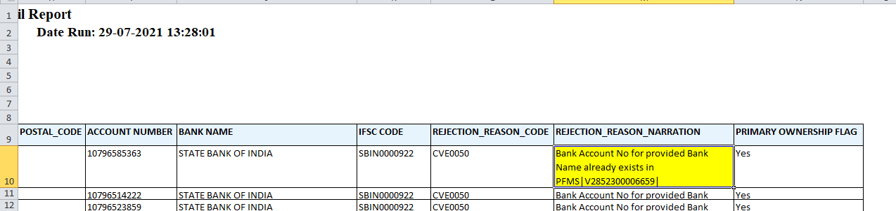

Users can then run a custom program named ‘FCI PFMS merge bank account CVE0050’ in report mode to view the details of the vendor registered at PFMS with same bank account and bank name as output. The program is available with Payables responsibility. The input parameters for this concurrent program are discussed in detail below.
NOTE: This process is only applicable for rejected vendors with PRIMARY OWNERSHIP FLAG ‘Y’.
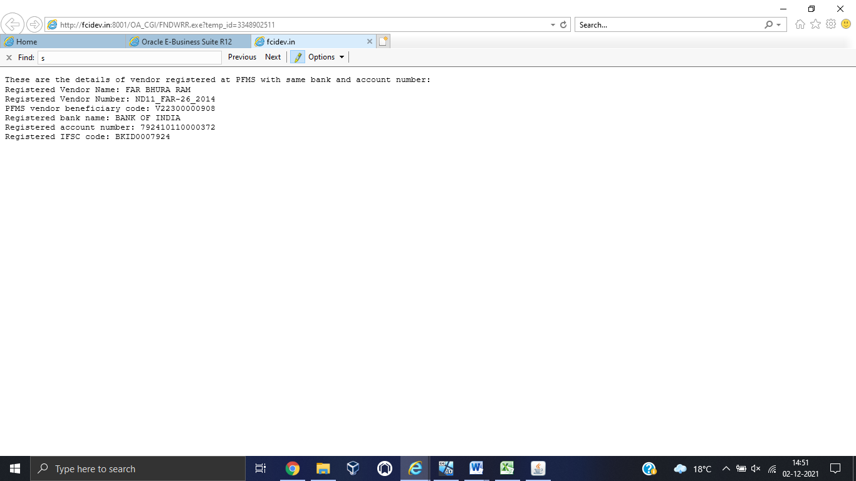
Once user has verified the bank details of a rejected vendor against the details of registered vendor, user can then decide if they want to modify the bank details of the rejected vendor, If the modified bank details are different from vendor ‘V00000000000’ it will get registered at PFMS as a separate record. However, if user wants to keep the same bank details because of which the vendor record is rejected then user can follow below approach and run the same custom process in fix mode (report mode=N) with following inputs.
Input parameter | Mandatory | Description
PFMS agency code | Y | PFMS agency code of the vendor already registered at PFMS with same bank and account number. This can be seen in the REJECTION_REASON_NARRATION column from FCI PFMS Rejected Vendor Detail Report
Report Mode | Y | REPORT/FIX
Rejected Vendor Number | Y | Supplier Number for rejected vendor from report FCI PFMS Rejected Vendor Detail Report
Rejected Vendor Site | Y | Vendor site at which secondary account ownership is to be given
Rejected Bank Name | Y | Rejected Bank name exactly as in report FCI PFMS Rejected Vendor Detail Report
Rejected Account Number | Y | Rejected Account Number exactly as in report FCI PFMS Rejected Vendor Detail Report
Rejected IFSC code | Y | Rejected IFSC code exactly as in report FCI PFMS Rejected Vendor Detail Report

Running the process in fix mode will have following results:
- The program will end_date (with sysdate) current bank account which is assigned to the rejected vendor at all levels (vendor/site) and delete the rejected record from PFMS vendor master table which was reflecting in report.
- It will assign the bank account of registered vendor with PFMS agency code ‘V00000000000’ to the rejected vendor at the vendor site specified by the end user in input parameter ‘Rejected Vendor Site’.
- The rejected vendor will be made a secondary bank account owner of the registered bank account.
- The rejected vendor will be made secondary owner in the bank account of the vendor ‘V00000000000’ having same bank name and account number. Thus whenever there is a payment made for any of the two vendors, it will be reported to PFMS with PFMS agency code ‘V00000000000’. Ensuring reporting of EAT for both the vendor transactions.
